Phase 3
Pokatha Saku
202101698
CS4433
Individual Assignment

System design
Architecture:
Four-layer architecture
Why this architecture:
The system is moderately sized and runs on one school computer, so a simple structure is easier to build and explain
Rejected alternative:
Client-server or three-tier with a database server. The IT officer said the internet is unreliable and the computers are old. A database server adds installation and maintenance cost that the school’s technicians can’t support
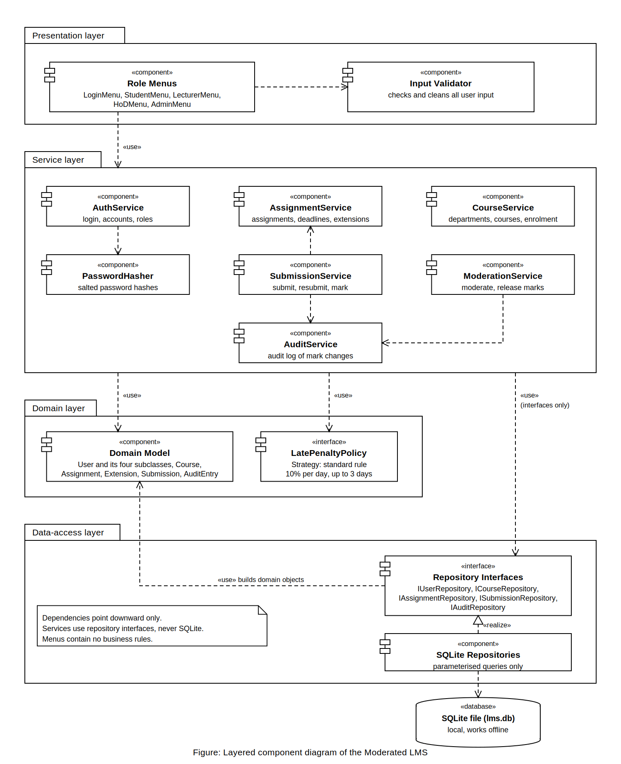

Class diagram
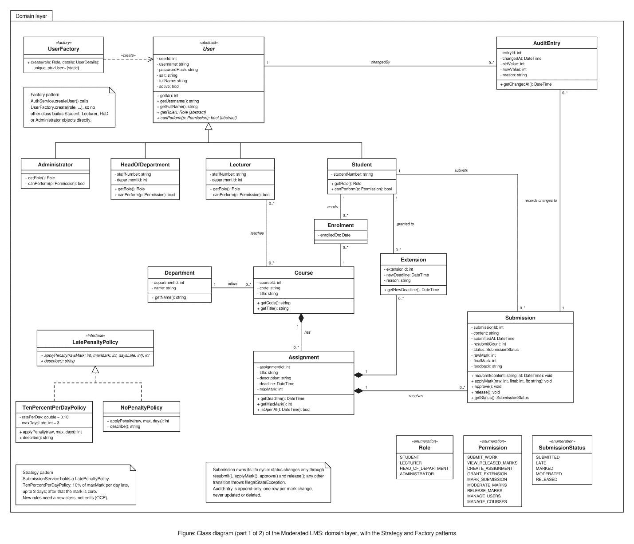
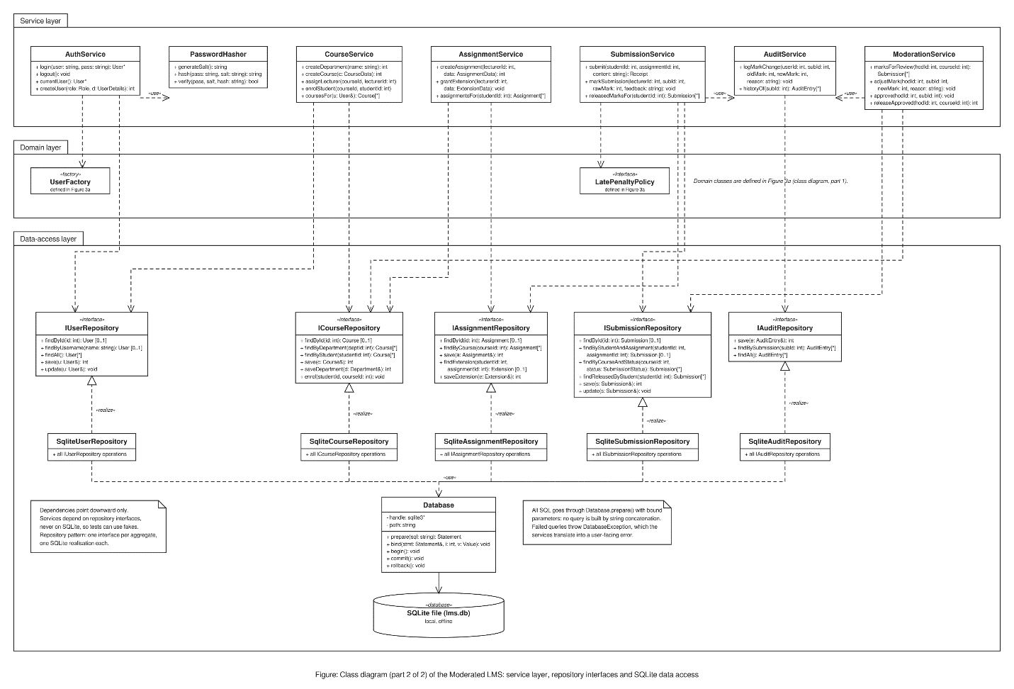

Strategy (LatePenaltyPolicy). The Head of Department’s rule is 10% per day for up to 3 days, then zero. Rules like this change. With Strategy, a new rule is a new class, and SubmissionService doesn’t change. NoPenaltyPolicy also makes tests easy.
Repository (Repository and Sqlite) It hides SQL from the business logic and keeps all queries parameterized in one layer. That satisfies the brief’s requirement that SQLite is accessed only through a data-access layer. One interface per aggregate keeps each interface small.
Factory (UserFactory). Creating a user needs role-specific construction (Student, Lecturer, HeadOfDepartment, Administrator). Putting it in one factory means no other code uses new on concrete user classes, and a new role is added in one place.
Considered and not used: Observer. Notifications aren’t in the requirements, so adding it would be over-engineering.

SOLID
Single responsibility: each service has one job. AuditService only audits, PasswordHasher only hashes, and Submission only owns its life cycle.
Open/closed: new penalty rules extend LatePenaltyPolicy without edits. CR1 (class-wide extensions) extends AssignmentService without touching the marking logic.
Liskov substitution: any User subclass can be used where User is expected. Each overrides getRole() and canPerform() without breaking the base contract.
Interface segregation: five small repository interfaces instead of one large one, so a service sees only the operations it needs.
Dependency inversion: services depend on abstractions (I…Repository, LatePenaltyPolicy), injected through constructors. They never depend on SQLite directly.

Behavioral models:
- State Machine: it makes the allowed transitions explicit. Illegal ones, such as resubmitting after the deadline, throw IllegalStateException. Students see marks only in Released, which resolves the Principal versus Lecturer conflict. The lecturer still marks at once.
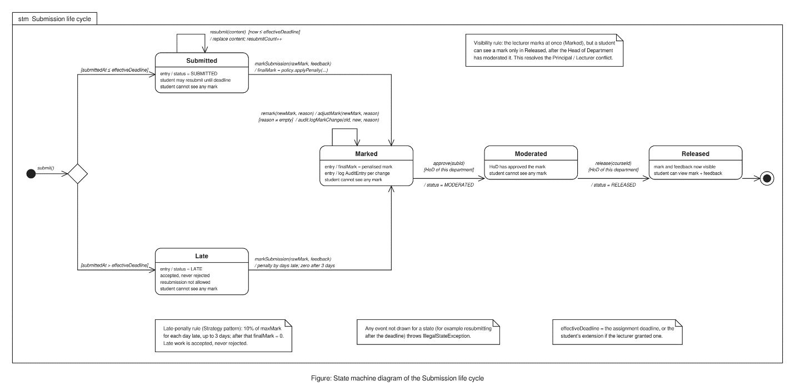
- Activity diagram: it shows who does what end to end and where decisions happen: on time versus late, resubmit, and approve versus adjust.
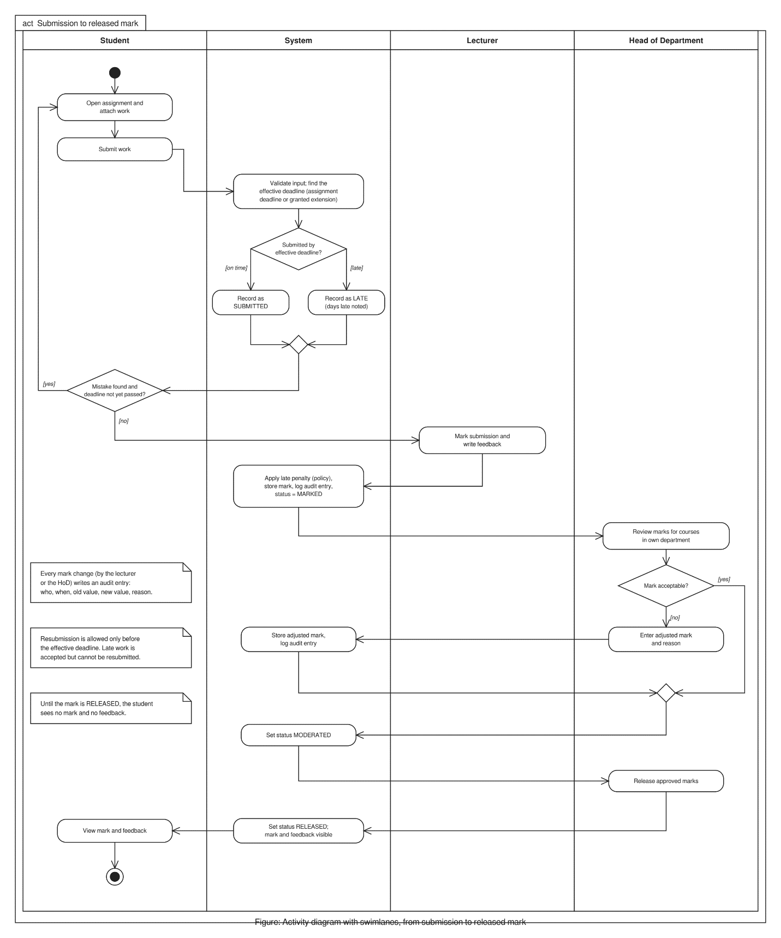
- Sequence diagrams: they show the layering in action (menu → validator → service → repository) and the exception paths, such as late resubmission and access denied.
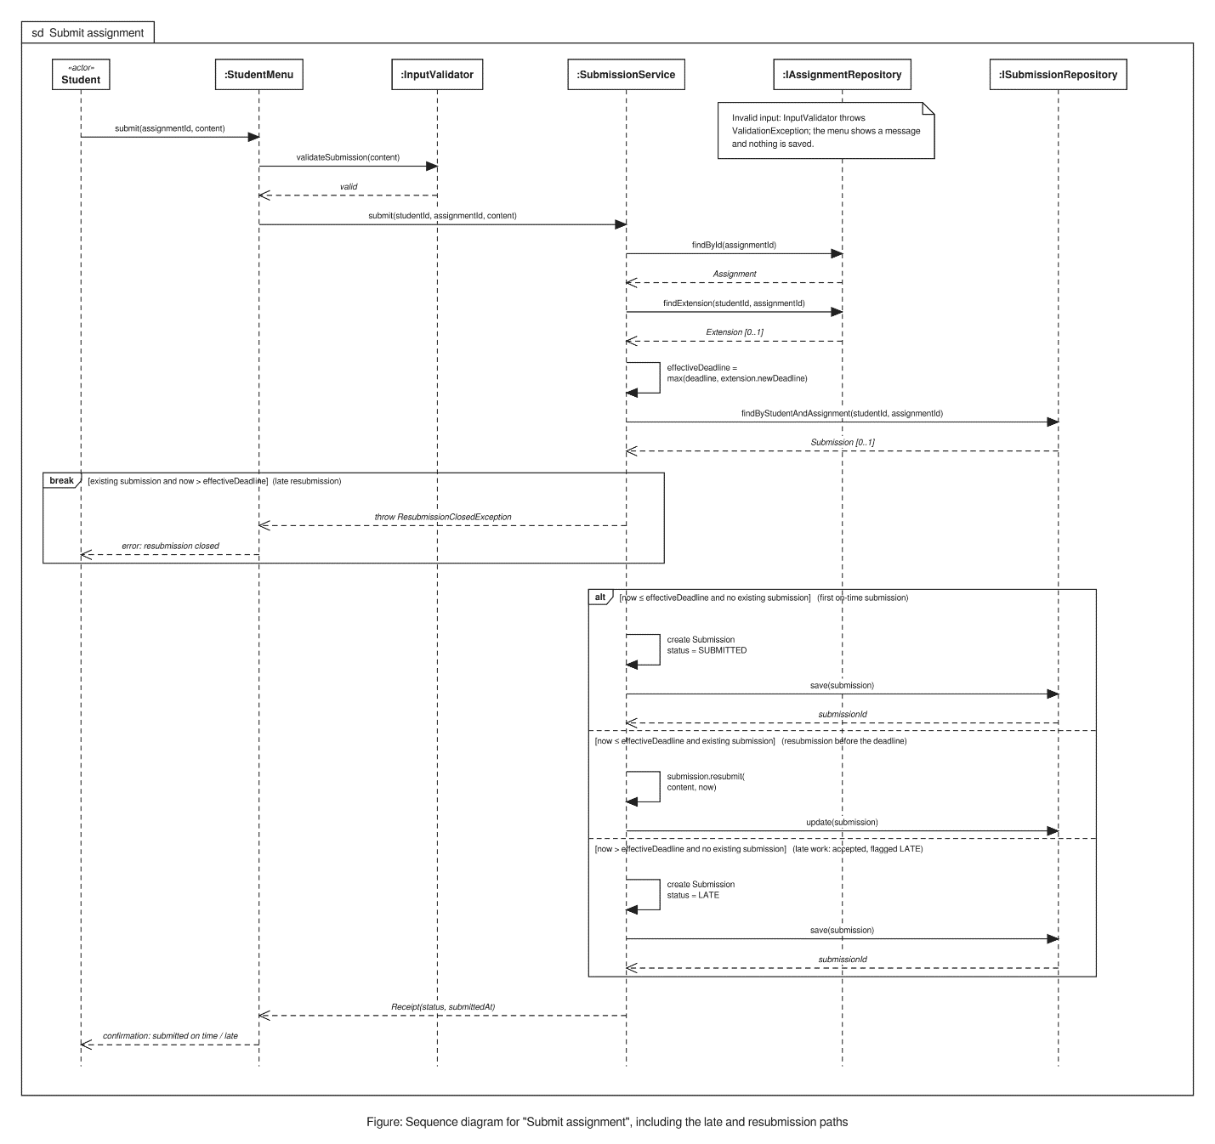
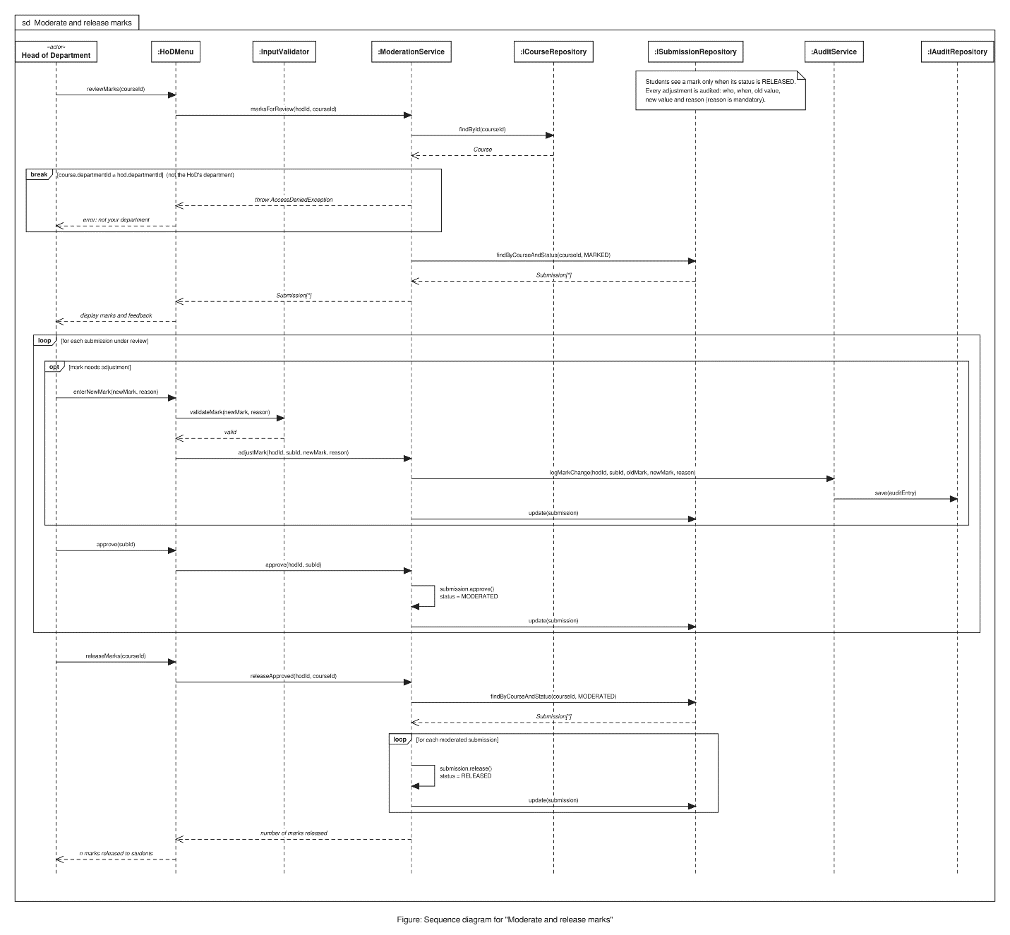

Database design:
Normalisation argument (3NF):

1NF: every column is atomic, and there are no repeating groups. Enrolments are rows, not lists.
2NF: enrolment has a composite key (student_id, course_id). Its only non-key column, enrolled_on, depends on the whole key.
3NF: non-key columns depend only on their own table’s key. A department’s name is stored once in department, not repeated in course or users


